Growth is confined to certain region called as growing points these points are called:
A. Roots
B. Shoots
C. Meristems
D. Leaf
ANSWER: C
The group of meristematic cells found in apices of roots and stem______.
A. Intercalary
B. Apical meristem
C. Lateral meristem
D. All of the above
ANSWER: B
Types of meristematic tissues are recognized in plants:
A. Apical meristems
B. Lateral meristems
C. Both A and B
D. None of these
ANSWER: C
_________tissues are present at the apex of roots and stems
A. Apical meristems
B. Lateral meristems
C. Both A and B
D. None of these
ANSWER: A
_______________are located on the lateral sides of roots and shoot
A. Apical meristems
B. Lateral meristems
C. Both A and B
D. None of these
ANSWER: B
The growth by apical meristems is called:
A. Primary growth
B. Secondary growth
C. Tertiary growth
D. None of these
ANSWER: A
The increase in the diameter of plants by lateral meristems is called:
A. Primary growth
B. Secondary growth
C. Tertiary growth
D. None of these
ANSWER: B
__________ occurs by the meristems of two apices so it results in an increase in the size of plants.
A. Primary growth
B. Secondary growth
C. Tertiary growth
D. None of these
ANSWER: A
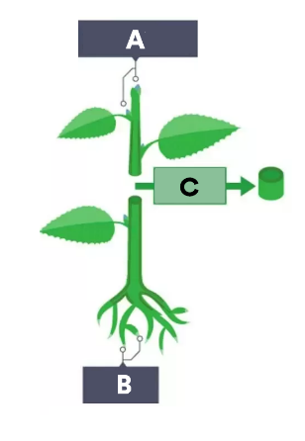
What does A represent in the given diagram?
A. Shoot apical meristems
B. Lateral meristems
C. Root apical meristems
D. Stele
ANSWER: A
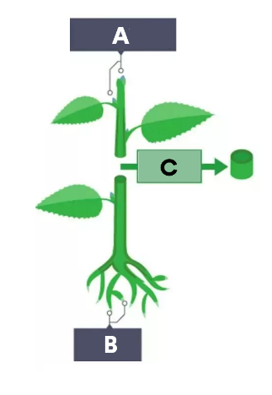
What does B represent in the given diagram?
A. Shoot apical meristems
B. Lateral meristems
C. Root apical meristems
D. Stele
ANSWER: C
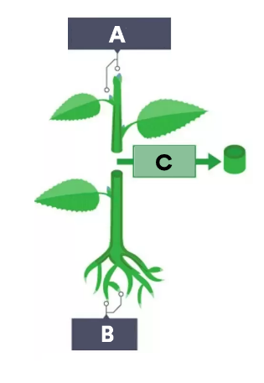
What does C represent in the given diagram?
A. Shoot apical meristems
B. Lateral meristems
C. Root apical meristems
D. Stele
ANSWER: B
_________are responsible for the increase in girth of plant parts
A. Apical meristems
B. Lateral meristems
C. Both A and B
D. None of these
ANSWER: B
Apical meristems give rise to the primary plant body and are
A. Responsible for the increase in girth of plant parts
B. Responsible for the extension of the roots and shoots
C. Responsible for the secondary growth
D. Responsible for the nutrition supply
ANSWER: B
A permanent irreversible increase in size, weight, shape and structure is called
A. Germination
B. Development
C. Growth
D. None of these
ANSWER: C
Growth is brought about by
A. Cell Division
B. Nuclear Division
C. Germination
D. None of these
ANSWER: A

